TIME MACHINE
BY: Vic Tanev (Sydney-AU)
(ONLY EXPERIMENTIAL- and a FANTASY at the moment)
1 N-time 2.
E -time w-time
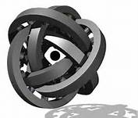
S-TIME

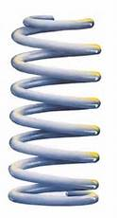
1,2,3,4, Combination of MAGRAV
Coils – sizes, with variable velocity
And variable supply to it.
Turning clockwise or anticlockwise
Producing different magrav fields
3 TD Coil-upper atmospheres, Universe
MAGRAV ENERGY and FIELDS from 1.earth, MIDDLE SPIRAL, and 3 Universe
Is Induced in 1,2,3,4, Combination of Coils.
Then you can move in either direction by
Increasing the velocity in required direction or back in direction you come from.
1st Coil - Earth
By Changing the MAGRAV fields (ONLY MY WAY OF THINKING & EXERCISE) COULD BE possible to not only change yourself from old to young, by changing the MAGRAV fields within you, you are changing the molecular structure of yourself therefore you changing your physical, mental and spiritual personality also you can go back in time or forward in time by changing and varying the velocity of the MAGRAV FIELDS.
(ONLY MY FANTASY and THINKING)

3. 4.

